Networks Fundamentals II Homework: In a Network Far, Far Away!

Mission 1

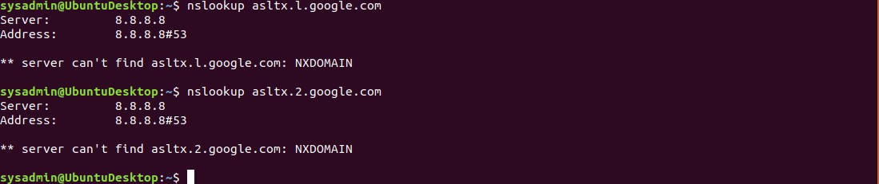

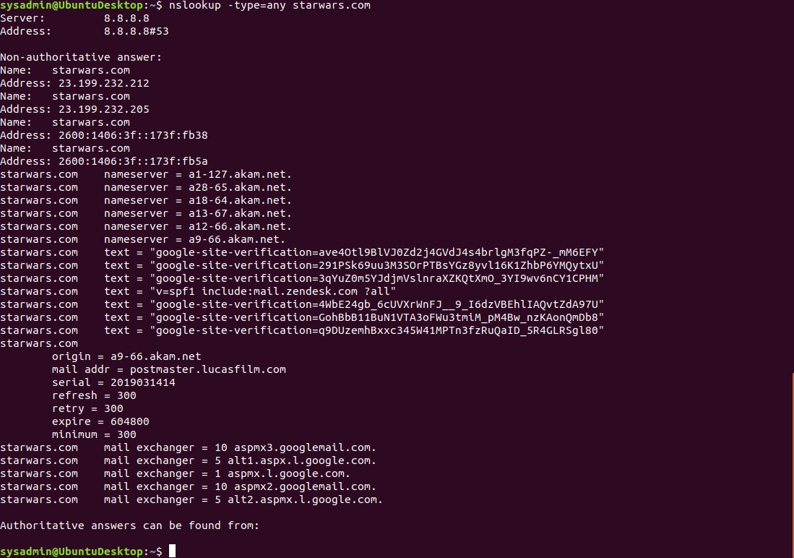

-The Resistance can not receive any emails because their MX records are not set to their proper mail servers. The primary mail server should read as: alt1.aspx.l.google.com and the secondary mail server: alt2.aspmx.l.google.com.

-The DNS record needs to be corrected to:

Starwars.com mail exchanger = 1 asltx.l.google.com

Starwars.com mail exchanger = 5 asltx.2.google.com

Misson 2

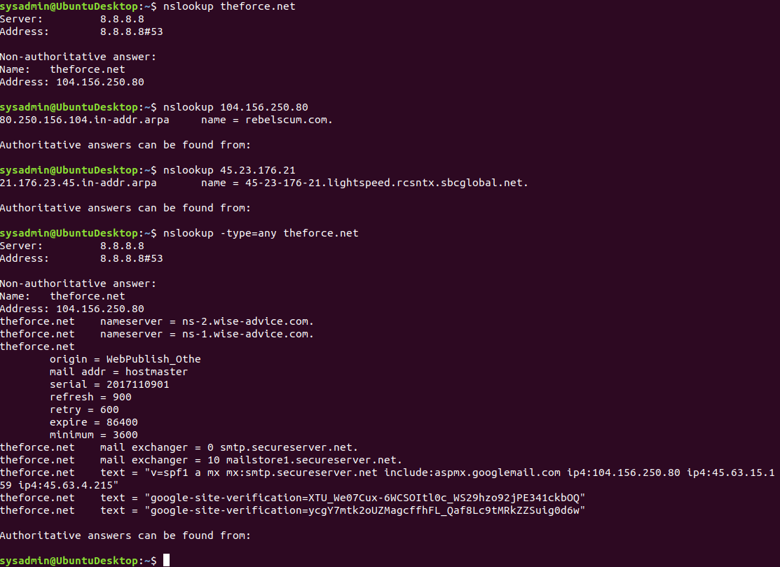

-Why the Force’s emails are going to the spam folder:

The Force has not updated their DNS text records. The SPF pointer has recently been changed to the new mail server of 45.23.176.21.

-The correct DNS record should be:

theforce.net text = "v=spf1 a mx mx:smtp.secureserver.net include:aspmx.googlemail.com ip4:104.156.250.80 ip4:45.63.15.159 ip4:45.63.4.215

Mission 3

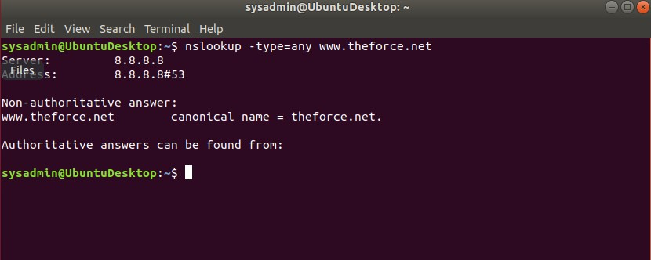

-The sub-page of resistance.theforce.net is not redirecting to [www.theforce.net](http://www.theforce.net).

-The CNAME DNS record correction should be made to:

[www.theforce.net](http://www.theforce.net) canonical name = theforce.net

and

resistance.theforce.net canonicalname = [www.theforce.net](http://www.theforce.net)

-The CNAME DNS record is missing a reference from resistance.theforce.net to [www.theforce.net](http://www.theforce.net).

Mission 4

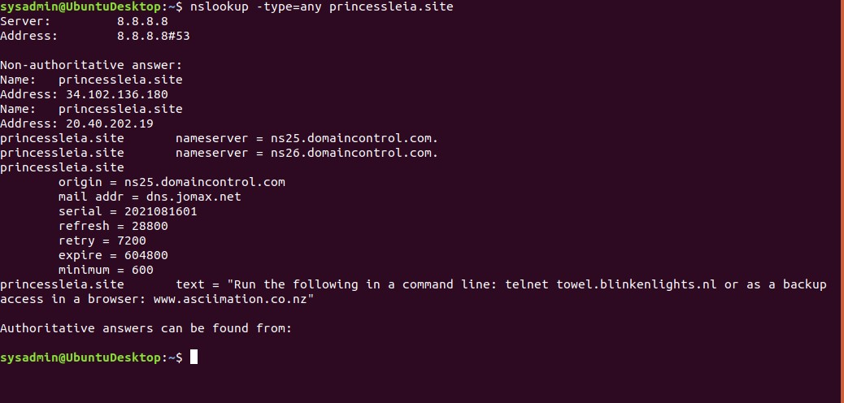

-Confirm the DNS records for pricessleia.site Current name servers:

princessleia.site nameserver = ns25.domaincontrol.com

princessleia.site nameserver = ns26.domaincontrol.com

To fix the DNS record and prevent this from happening again.

Add a reference to the backup DNS server:

princessleia.site nameserver = ns26.domaincontrol.com

princessleia.site nameserver = ns2.galaxybackup.com

Mission 5

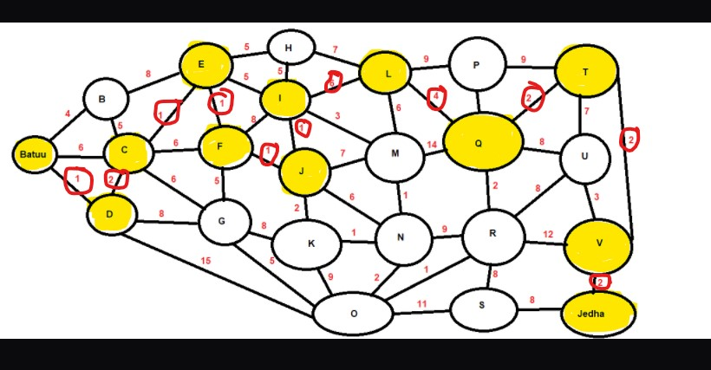

-The OSPF shortest path from Batuu to Jedha:

D 1, C 2, E 1, F 1, J 1, I 1, L 6, Q 4, T 2, V 2, Jedha 2 Total: 23 Hops or Parcec’s! (A slow Cruiser)

Planet N not in route:

D, C, E, F, J, I, L, Q, T, V

Planet Batuu - D - C -E -F - J - I - L - Q - T - V - Planet Jedha

Mission 6

Darkside.pcap

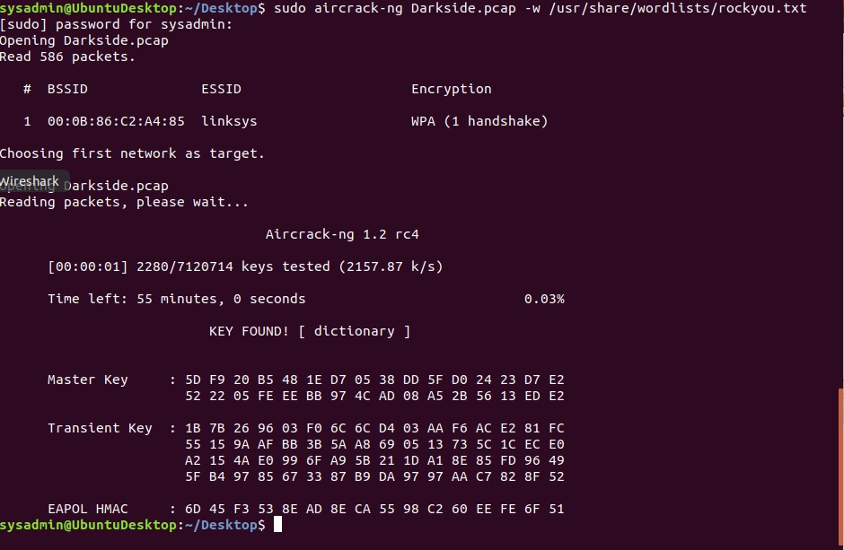

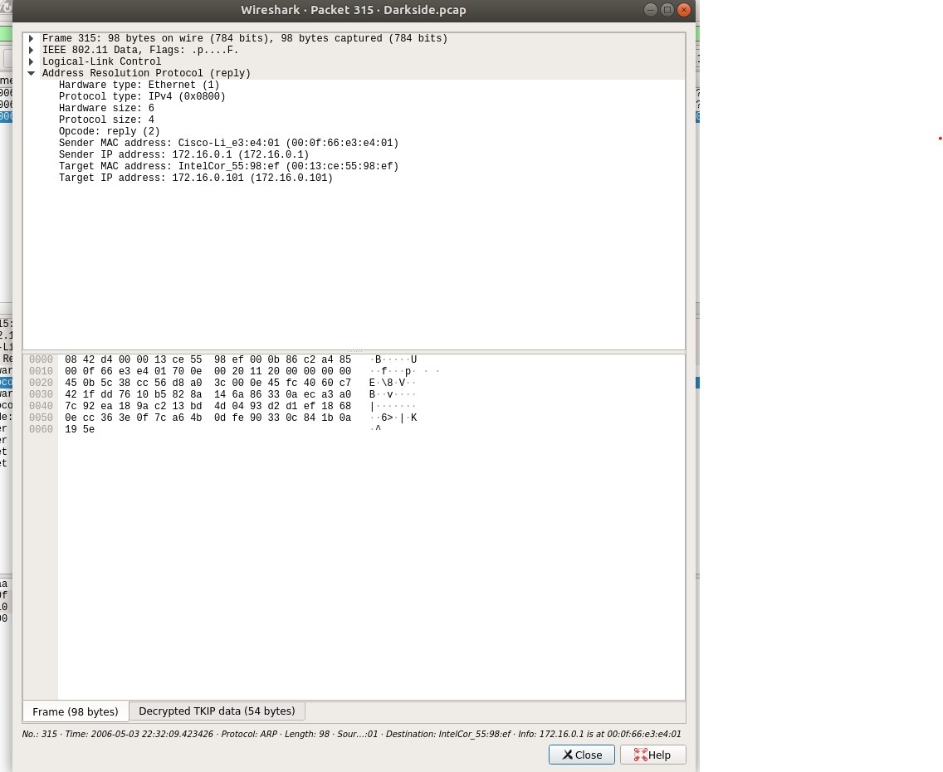

The resistance will attack these IP and Mac Addresses:

172.16.0.101 at 00:13:ce:55:98:ef

and

172.16.0.1 at 00:0f:66:e3:e4:01

Mission 7